Watch the Terraform-03 video.
Execute the script shown in the video.
Using by Variables
Always match your (main.tf ) name variable name with your variable type
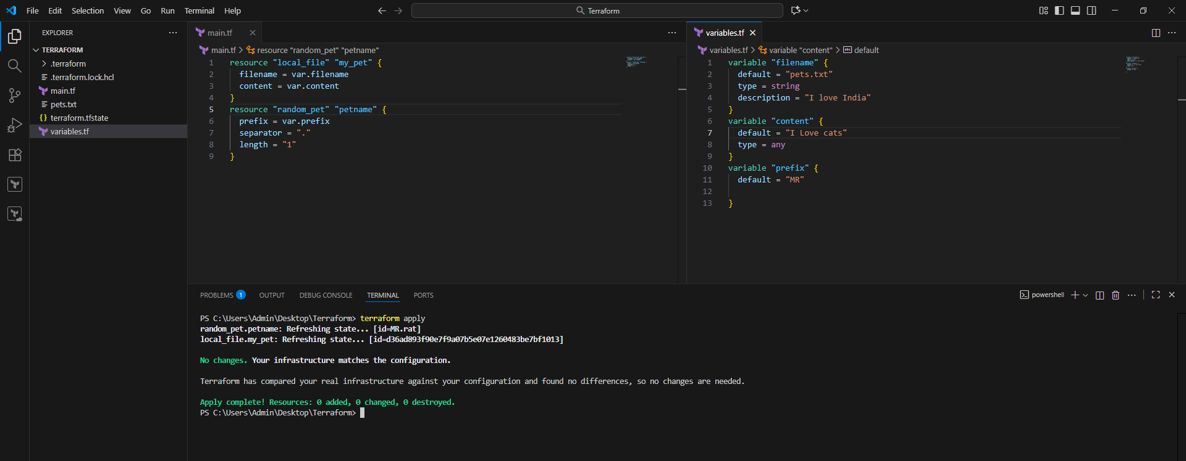
Interactive mode
If we declared empty variables there is no content then we execute terraform apply
Terraform automatically will ask the enter the value these type variables are called interactive mode
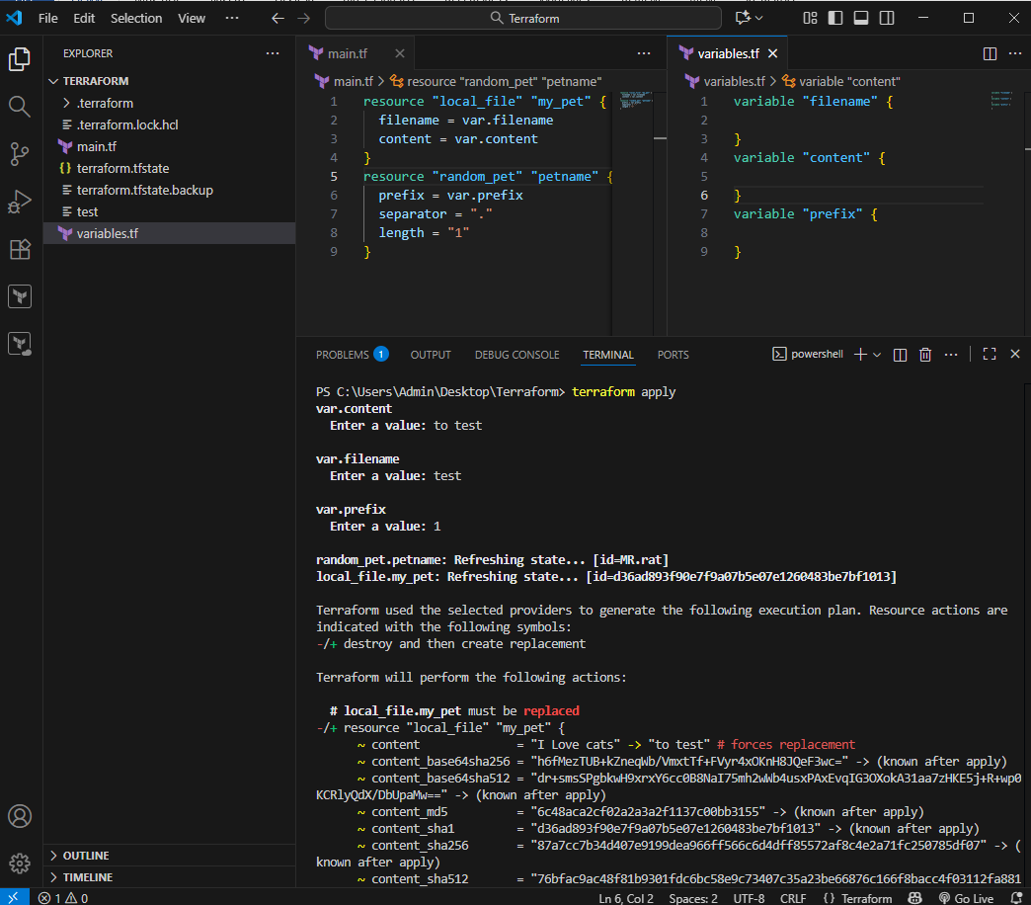

Command Line Flags(CLF)
Instead of passing them in variable.tf I can declare my variable
Terraform apply –var “filename=test.txt” –var “content=I love techie” –var “prefix=MR”
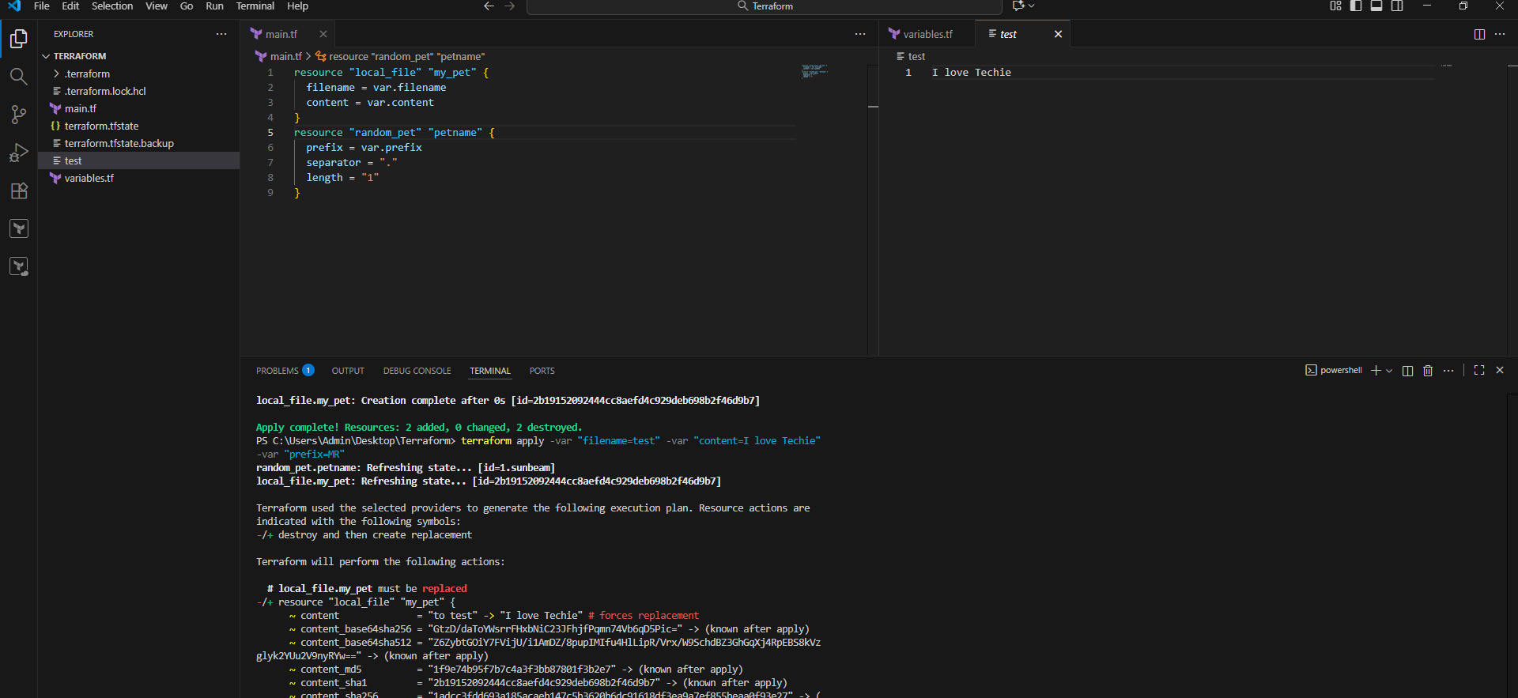

ENVIRONMENT VARIABLES
Set-Item -Path env:TF_VAR_filename –value "Wild.txt"
Set-Item -Path env:TF_VAR_content -value "I Love Horizon"
Set-Item -Path env:TF_VAR_prefix -Value 'miss'
terraform apply
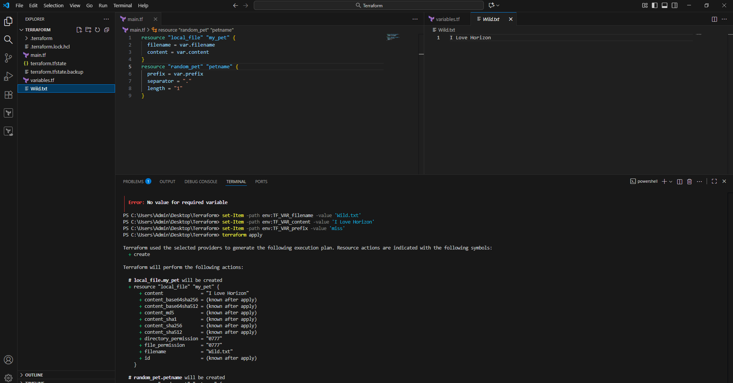
Varible definition precedence:
If we use multiple ways to define varibles for the same file then
terraform uses varible definition precedence
Terraform apply
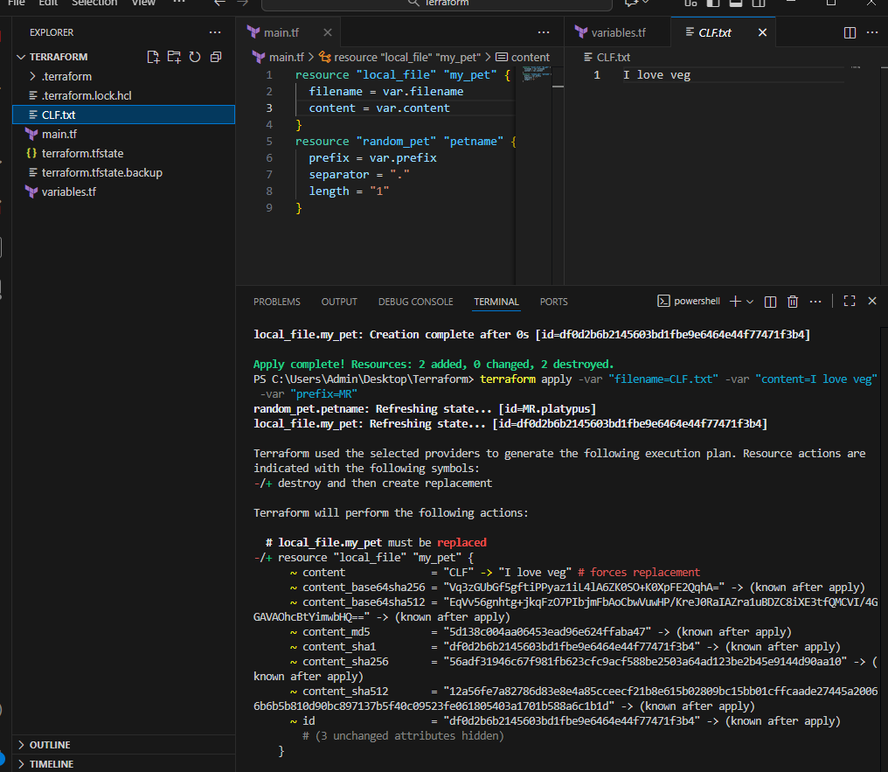
Varibale Precedence Order
1. Environment variables
2. Terraform.tfvars
3. *.auto.tfvars (alphabetical order)
4. -var or -var-file (Command Line Flags)
Resource Dependency
From the above main.tf we have local_file which is dependent on random_pet resource.
We are not mentioning that anywhere but still terraform will figure that out, we call
them as implicit dependecy.
Still we can define the dependency explicit by ourself using "depends_on" module
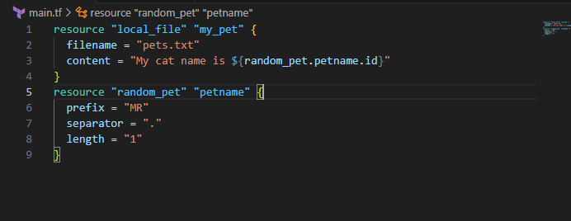
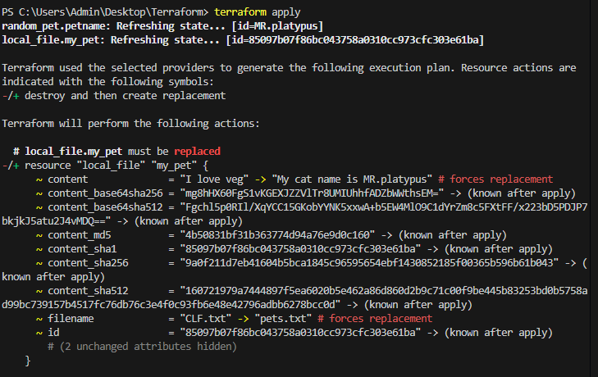
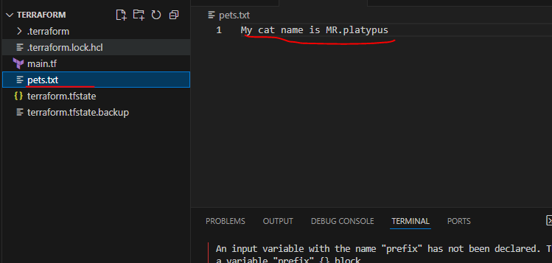
Terraform output
These are used to display the output of the resources.
Ex:
resource "random_pet" "pet_name" {
prefix = "MR"
separator = "."
length = "1"
}
output my-pet {
value = random_pet.pet_name.id
description = optional name
}
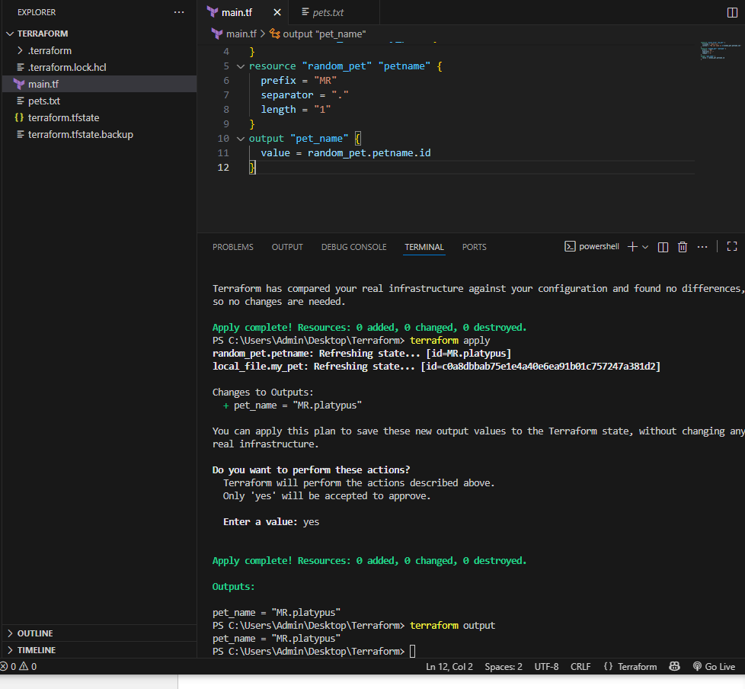
when we use terraform apply we can see the id as output.
we can use terraform output command to see the output of the resource
Terraform show:
The terraform show command displays the full
Terraform state — meaning all resources managed by(always store state file in S3)
Terraform and their current attributes.
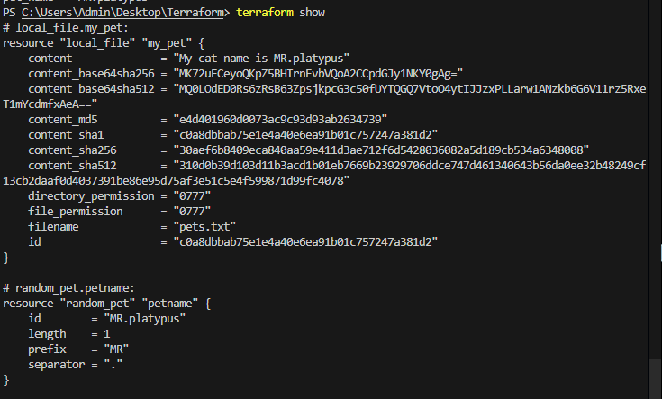
3) Integrate Terraform in Jenkins using the Terraform plugin.
Install Terraform on Jenkins
wget https://releases.hashicorp.com/terraform/1.8.5/terraform_1.8.5_linux_amd64.zip
unzip terraform_1.8.5_linux_amd64.zip
sudo mv terraform /usr/local/bin/
terraform –version
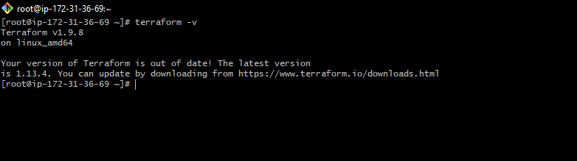
Step 2: Install Terraform Plugin in Jenkins
1. Go to Jenkins Dashboard → Manage Jenkins → Plugins →
Available Plugins.
2. Search for “Terraform” plugin.
3. Install it
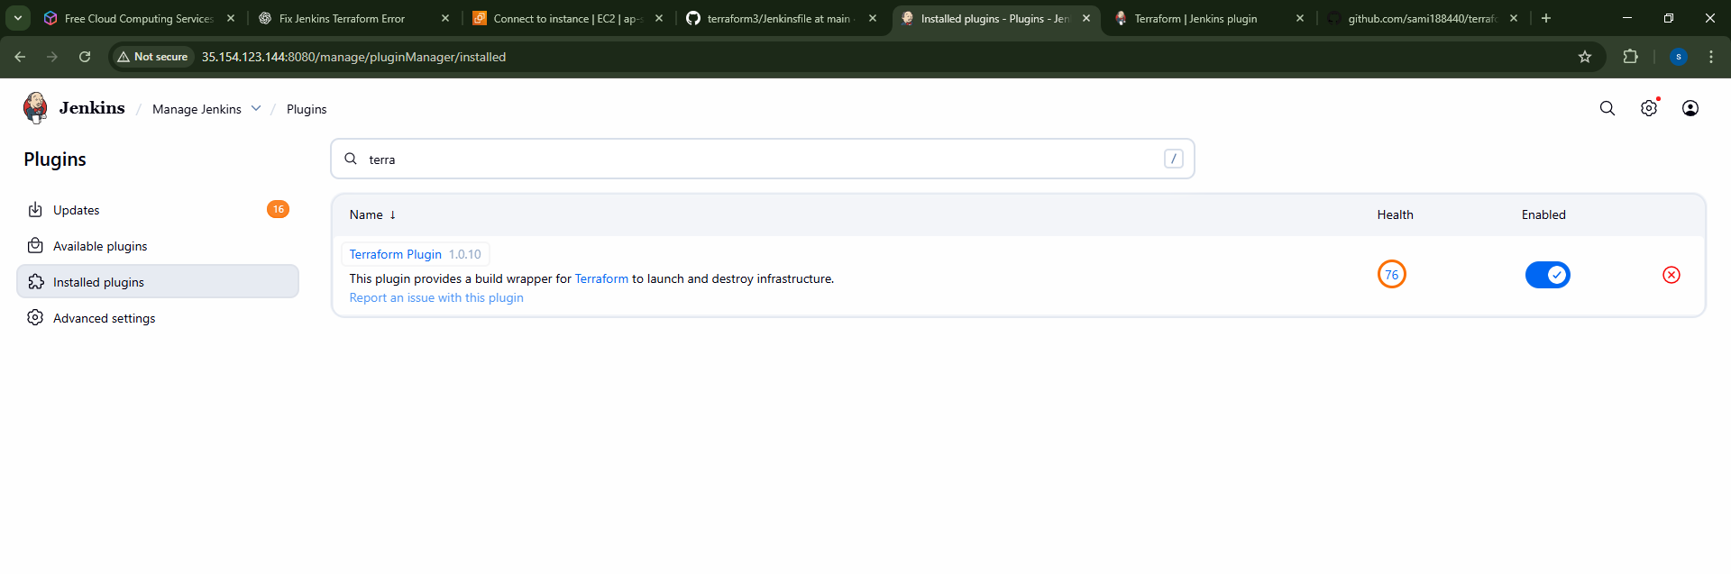
Step 3: Configure Terraform in Jenkins
1. Go to Manage Jenkins → Global Tool Configuration.
2. Find Terraform section.
3. Add a Terraform installation → give it a Name (example:
Terraform-1.8.5) and path if manually installed.
If plugin supports auto-install → let Jenkins download it.
If already installed → point Jenkins to /usr/local/bin/terraform
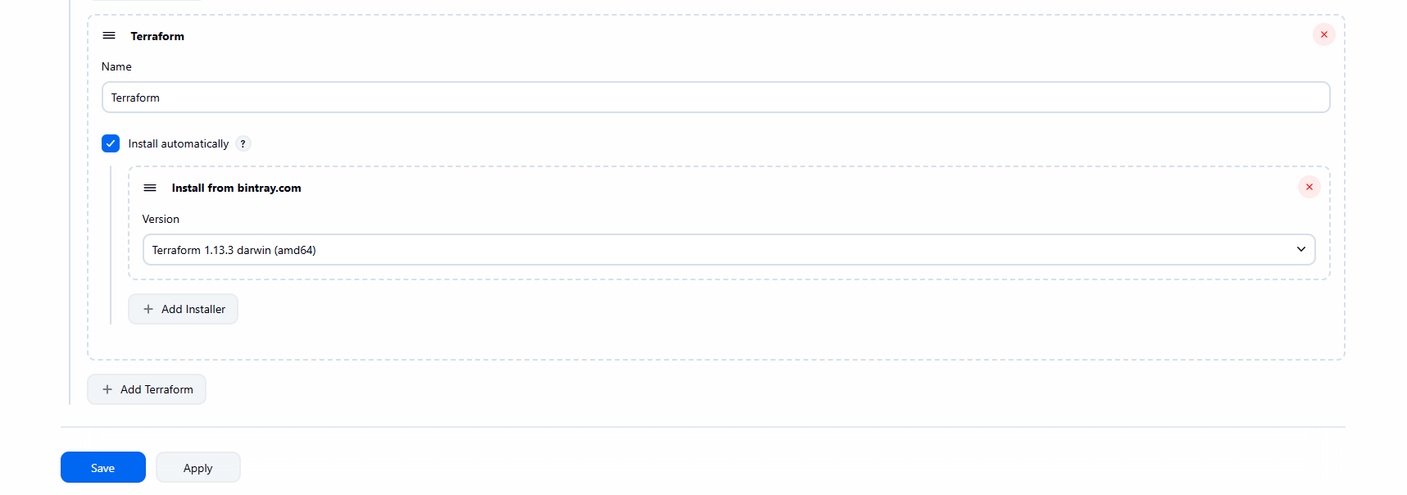
In github add these files
Main.tf
Variables.tf
Jenkinsfile
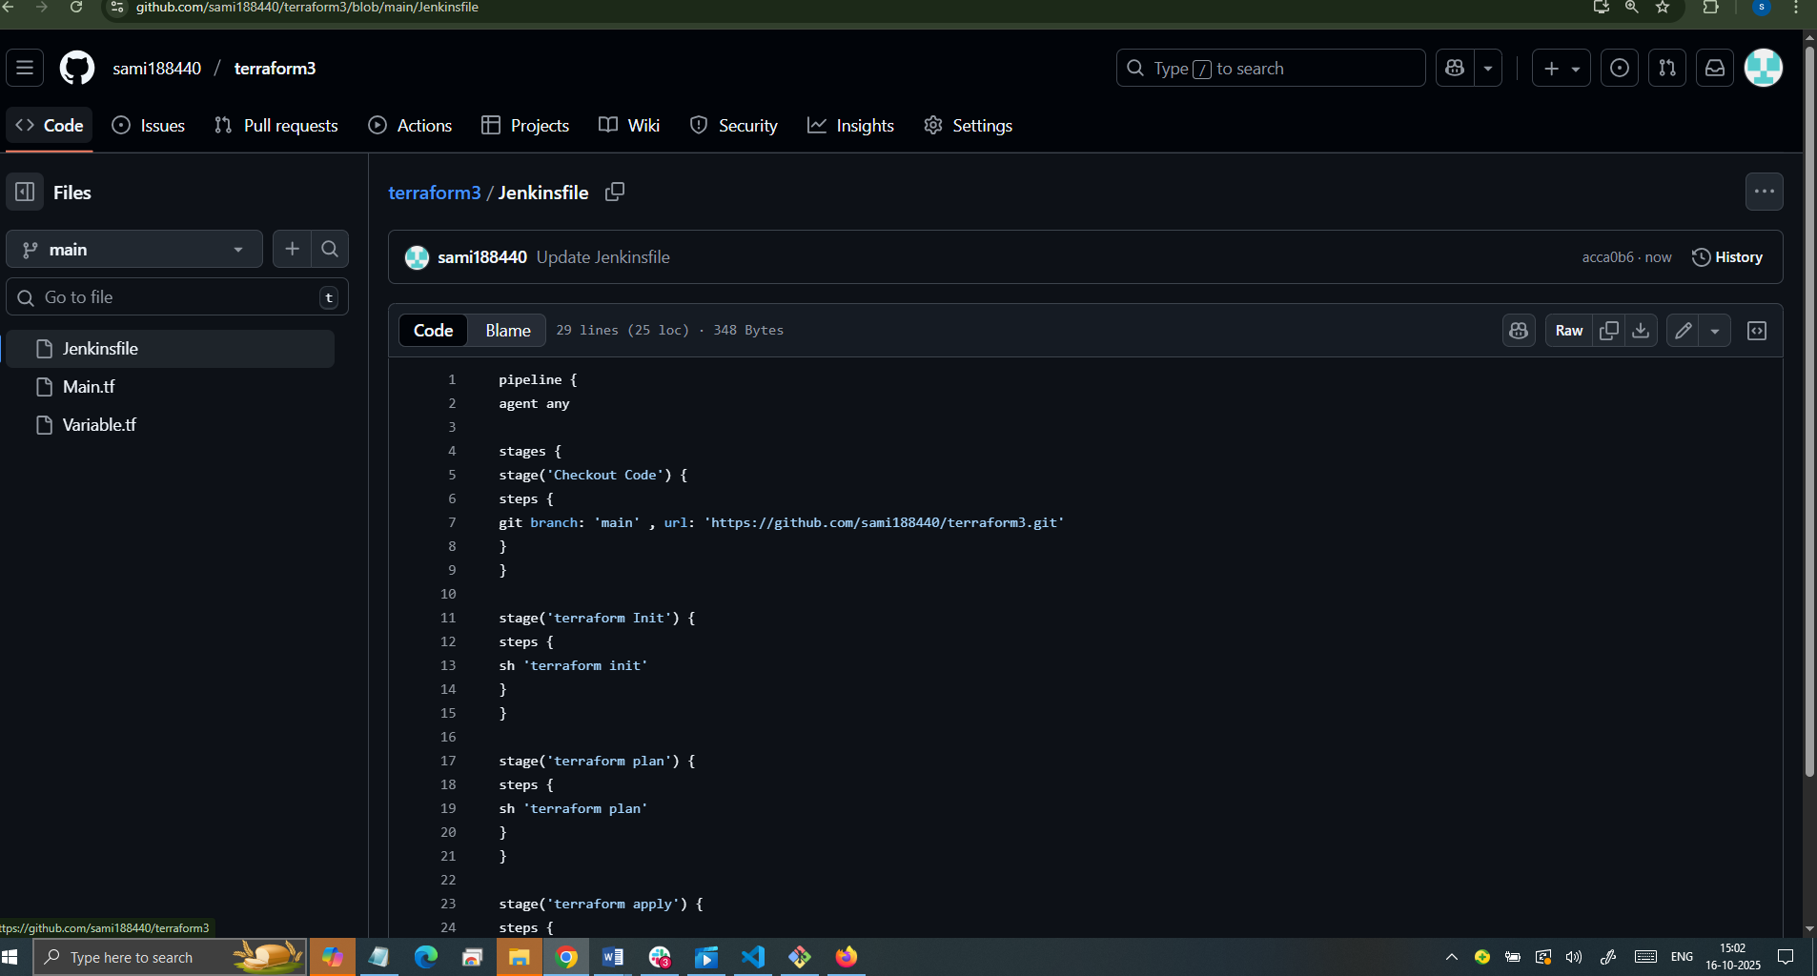
Go to Jenkins GUI and and create one job and give git hub url
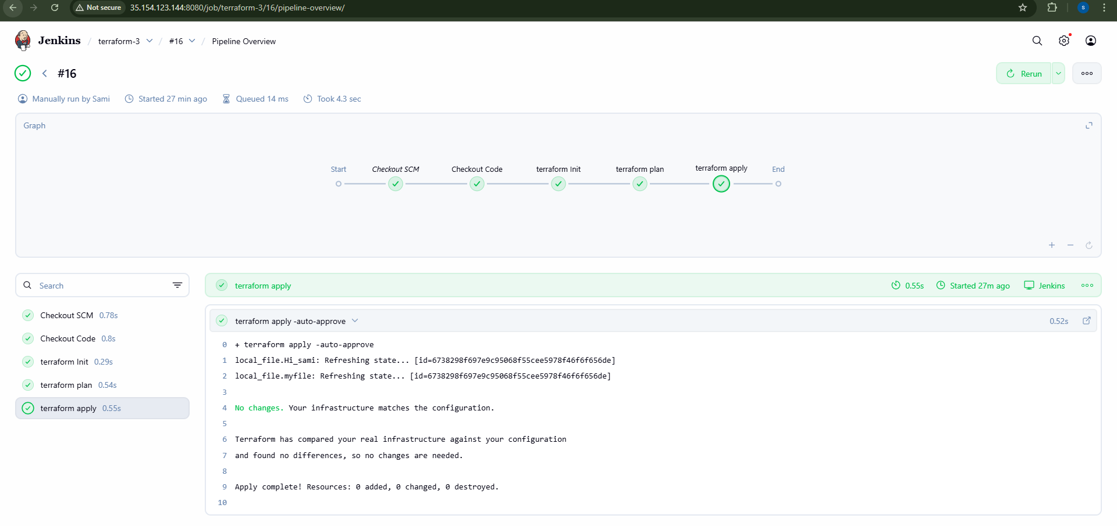

4)Create one Jenkins job using Maven Project for the code below with two stages:
Stage 1: Git clone
Stage 2: Maven Compilation Code: https://github.com/betawins/java-Working-app.git

Step 1
Install Maven Plugins
Go to Manage JenkinsAvailable Jenkins
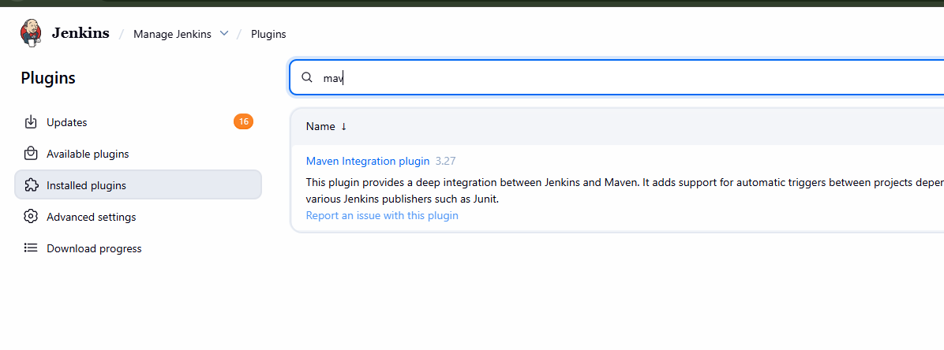
Step-2
Go to Manage Jenkins → Tool Configuration → Maven.
Add a Maven installation → check "Install automatically" → Jenkins
downloads Maven when needed
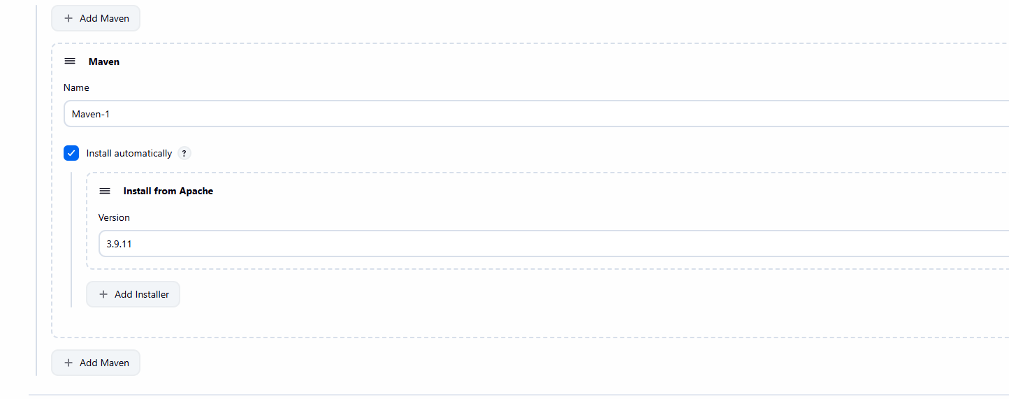

Step-3
Go to Jenkins Dashboard → New Item → Maven Project.
Enter job name → select Maven project.
In Source Code Management, select Git and add your repo URL
(https://github.com/betawins/java-Working-app.git)
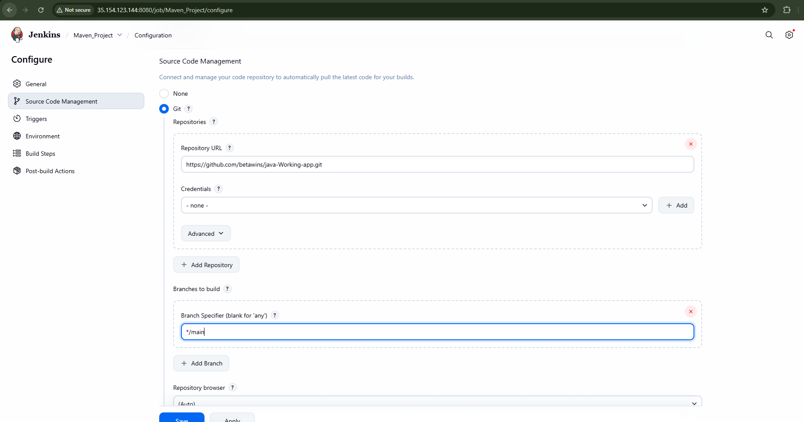

Buildnow
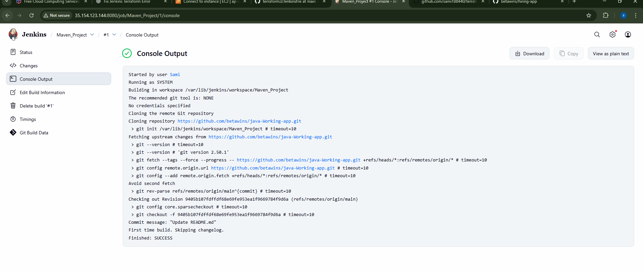
5)Use the same code and create a parameterized job in Jenkins with:
Stage 1: Git clone
Stage 2: Maven Compilation Code: https://github.com/betawins/java-Working-app.git
Install Jenkins
Install Maven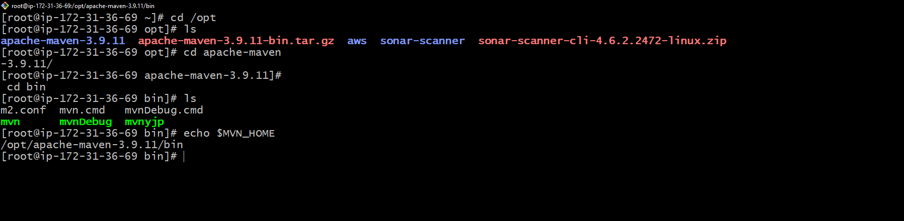
In the job configuration:
•Check “This project is parameterized”
•Add parameters:
String Parameter → Name: BRANCH_NAME, Default: main,
Description: Git branch to build
String Parameter → Name: GIT_URL, Default:Repo url,
String Parameter → Name: MAVEN_GOAL, Default: clean package, Description: Maven goal to run
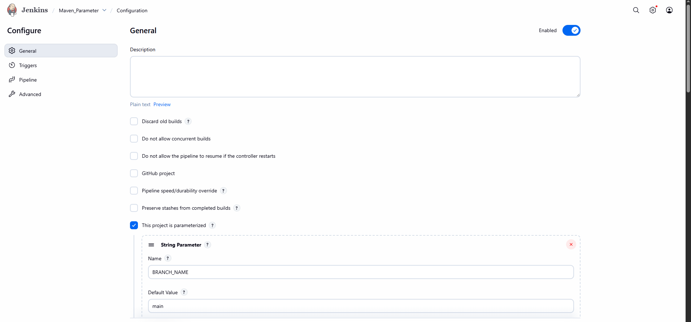

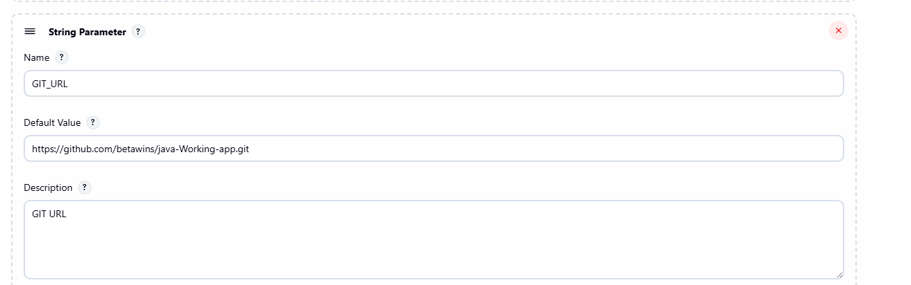
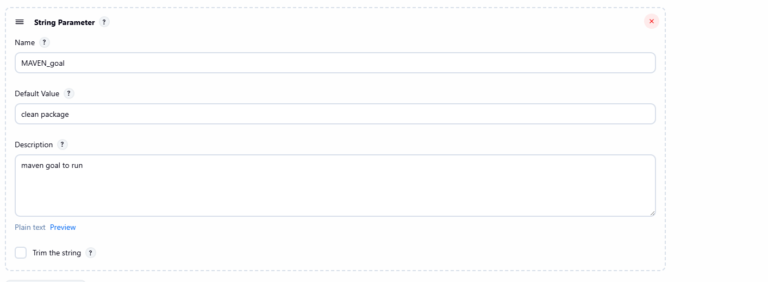

Add Scripted Pipeline Code
node {
def mvnHome = tool name: 'MVN_HOME', type: 'maven'
env.PATH = "${mvnHome}/bin:${env.PATH}"
stage('Git Clone') {
git branch: "${BRANCH_NAME}", url: 'https://github.com/betawins/java-Working-app.git'
}
stage('Maven Compilation') {
sh "mvn ${MAVEN_GOAL}"
}
stage('Archive Package') {
// Fix: WAR instead of JAR
archiveArtifacts artifacts: 'target/*.war', fingerprint: true
}
}

Save and build with parameters
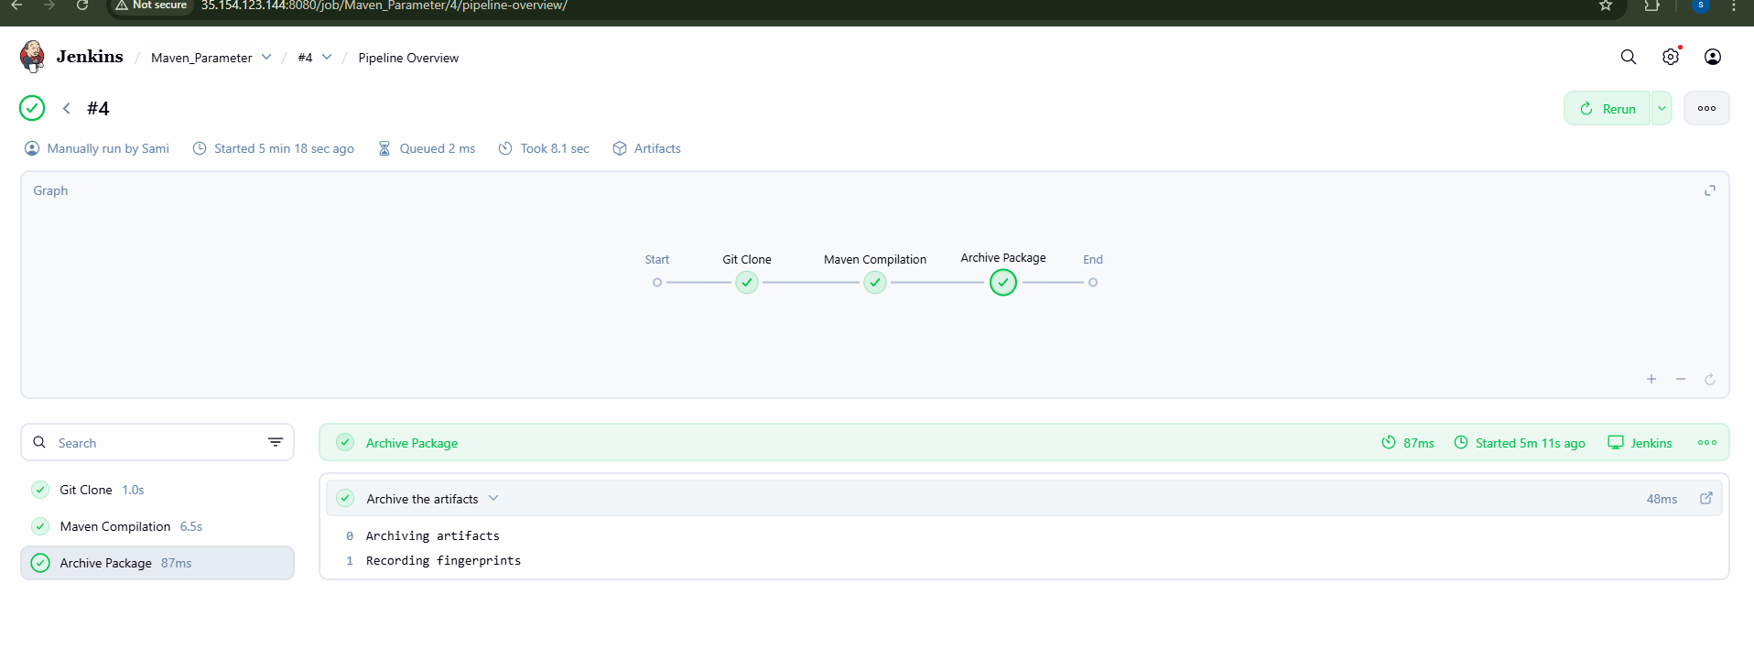
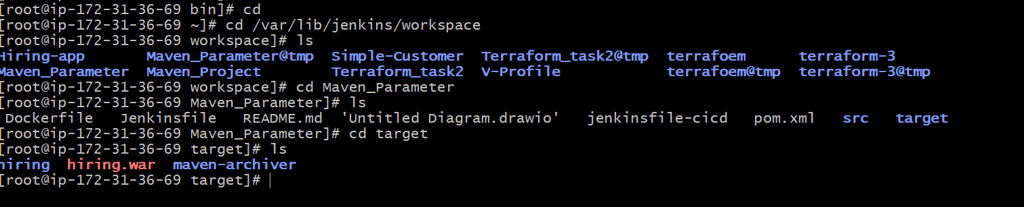
6)What are the global variables in Jenkins?
In Jenkins Pipelines, Global Variables are special built-in environment
variables and objects that Jenkins automatically provides. You don’t need to
define them — they are available everywhere in your pipeline.

Job & Build Info

•BUILD_ID → Unique build ID (timestamp)
•BUILD_NUMBER → Build number (incremental)
•BUILD_TAG → jenkins-${JOB_NAME}-${BUILD_NUMBER}
•JOB_NAME → Name of the Jenkins job
•JOB_BASE_NAME → Job name without folder path
•BUILD_URL → URL of the build in Jenkins
•JOB_URL → URL of the job

Node/Workspace Variables

•NODE_NAME → Name of the agent node running the build
•WORKSPACE → Path to the job’s workspace directory

Git/SCM Variables (when using git step)

•GIT_COMMIT → Commit hash being built
•GIT_BRANCH → Branch being built
•GIT_URL → Git repo URL

Special Global Objects (Pipeline DSL)

These are not strings, but powerful objects you can call methods on:
•steps → Provides pipeline steps (e.g. sh, git, echo)
•pipeline → DSL for declarative pipelines
•docker → Access Docker agents/containers if plugin is enabled
•input → Request user input
•credentials() → Inject stored credentials

Summary

•env → Environment variables
•params → Build parameters
•currentBuild → Build metadata
•Built-in vars → BUILD_NUMBER, JOB_NAME, WORKSPACE, BUILD_URL,
etc.
•SCM vars → GIT_COMMIT, GIT_BRANCH, GIT_URL

